End-to-End MLOps Pipeline for Heart Disease Prediction

Bhadriraju Prasanth
2024AA05717

1. Introduction
The objective of this project is to design, implement, and demonstrate an end-to-end MLOps pipeline for predicting heart disease using structured clinical data. The project focuses not only on building accurate machine learning models, but also on ensuring reproducibility, automation, traceability, and deployability, which are core principles of modern MLOps practices.
In real-world machine learning systems, model development alone is insufficient. Models must be versioned, tracked, tested, deployed, and monitored in a repeatable and automated manner. This assignment addresses these requirements by integrating multiple industry-standard tools including Python, MLflow, GitHub Actions, FastAPI, and Docker.
The final solution demonstrates: - Automated data ingestion and preprocessing - Multiple model training and comparison - Experiment tracking and model management - CI/CD automation using GitHub Actions - REST-based model serving using FastAPI - Containerized deployment using Docker
This report explains each stage of the pipeline in detail, supported by screenshots where applicable.

2. Project Architecture
The project follows a modular structure:
- src/: Core ML scripts (data ingestion, preprocessing, training)
- notebooks/: Exploratory data analysis
- api/: FastAPI model serving application
- .github/workflows/: CI/CD pipeline definition
- Dockerfile: Containerization configuration
The project follows a modular and scalable architecture, ensuring that each component of the ML lifecycle is clearly separated and independently maintainable.

2.1 Directory Structure
heart-disease-mlops/
│
├── src/ # Core ML scripts
│ ├── download_data.py
│ ├── data_preprocessing.py
│ ├── train.py
│
├── notebooks/ # Exploratory Data Analysis (EDA)
│ └── 01_eda.ipynb
│
├── api/ # FastAPI application
│ └── main.py
│
├── .github/workflows/ # CI/CD pipeline
│ └── ci.yml
│
├── tests/ # Unit tests
│
├── Dockerfile # Docker configuration
├── requirements.txt # Python dependencies
├── README.md

2.2 Architectural Rationale
· Separation of concerns: Training logic, serving logic, and automation logic are separated.
· Reproducibility: All steps are executable via scripts and CI pipelines.
· Scalability: The architecture can be extended to cloud-based storage, registries, and orchestration tools.

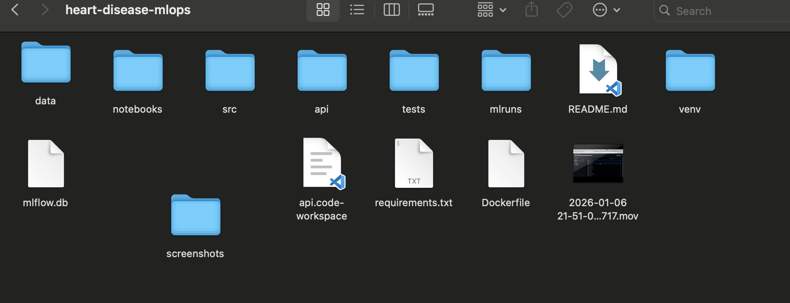
This structure ensures maintainability and reproducibility.

I have also created a Github Repo - Heart diseases for visualization and git pushes.

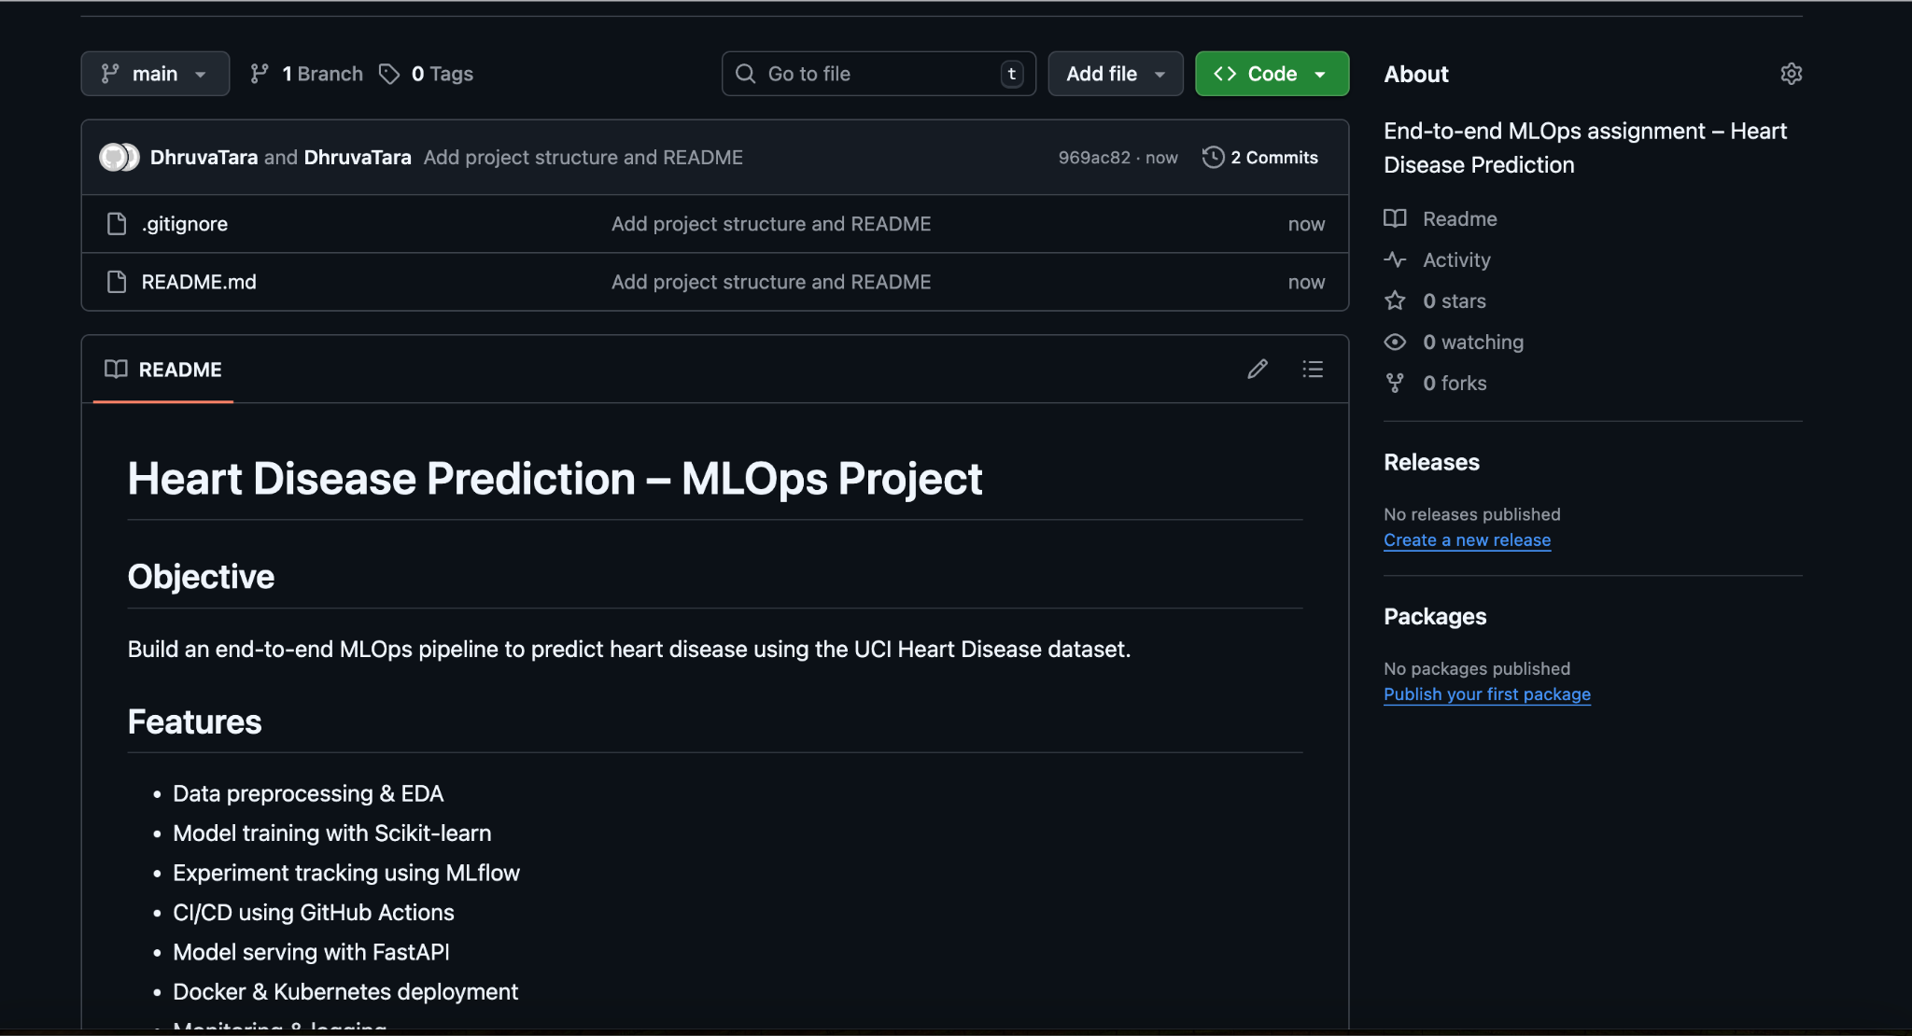
https://github.com/2024aa05717-source/heart-disease-mlops

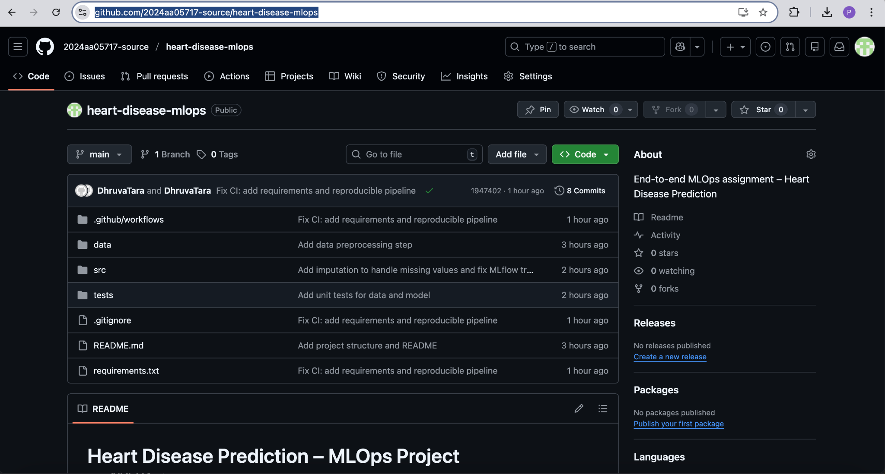

3. Setup and Installation Instructions
This section describes how to set up and run the project locally.

3.1 Prerequisites
· Python 3.9 or 3.10
· Git
· Docker Desktop (for containerization)
· VS Code or PyCharm

3.2 Environment Setup
# Clone the repository
git clone https://github.com/2024aa05717-source/heart-disease-mlops.git
cd heart-disease-mlops
# Create virtual environment
python -m venv venv
source venv/bin/activate
# Install dependencies
pip install -r requirements.txt

3.3 Running MLflow UI
mlflow ui
Access MLflow UI at:
http://127.0.0.1:5000

4. Exploratory Data Analysis (EDA)
Exploratory Data Analysis was conducted using Jupyter notebooks to understand the dataset structure, distributions, and relationships between variables.

4.1 Dataset Overview
The dataset contains patient health attributes such as: - Age - Sex - Chest pain type (cp) - Blood pressure - Cholesterol - Fasting blood sugar - ECG results - Heart disease indicator (target)

4.2 EDA Techniques Used
· Descriptive statistics (mean, median, variance)
· Missing value analysis
· Correlation heatmaps
· Feature-target relationship plots
These analyses helped identify important predictive features and informed preprocessing decisions.
(EDA screenshots attached below)

Data Ingestion and Preprocessing
The dataset is programmatically downloaded and stored locally. Preprocessing includes handling missing values, encoding categorical variables, and feature selection. All transformations are implemented as reusable scripts to ensure consistency across training and inference.

5.1 Data Ingestion
The dataset is programmatically downloaded using a Python script to avoid manual intervention. This ensures: - Repeatability - Automation - CI compatibility

5.2 Preprocessing Steps
· Handling missing values
· Encoding categorical variables
· Feature selection
· Train-test split
All preprocessing logic is implemented in reusable Python scripts, ensuring consistency between training and inference.

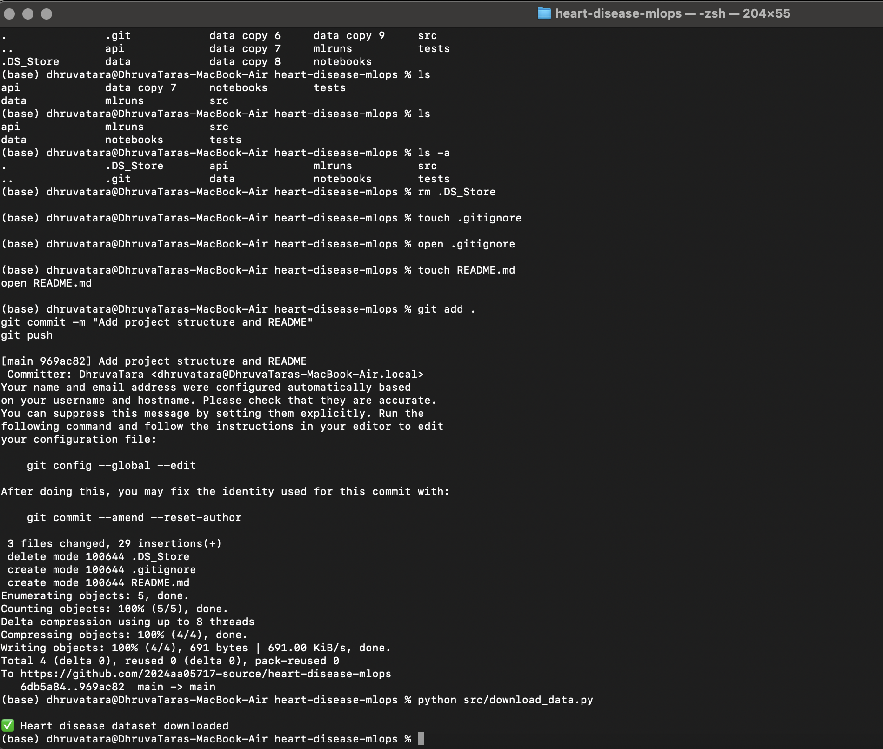

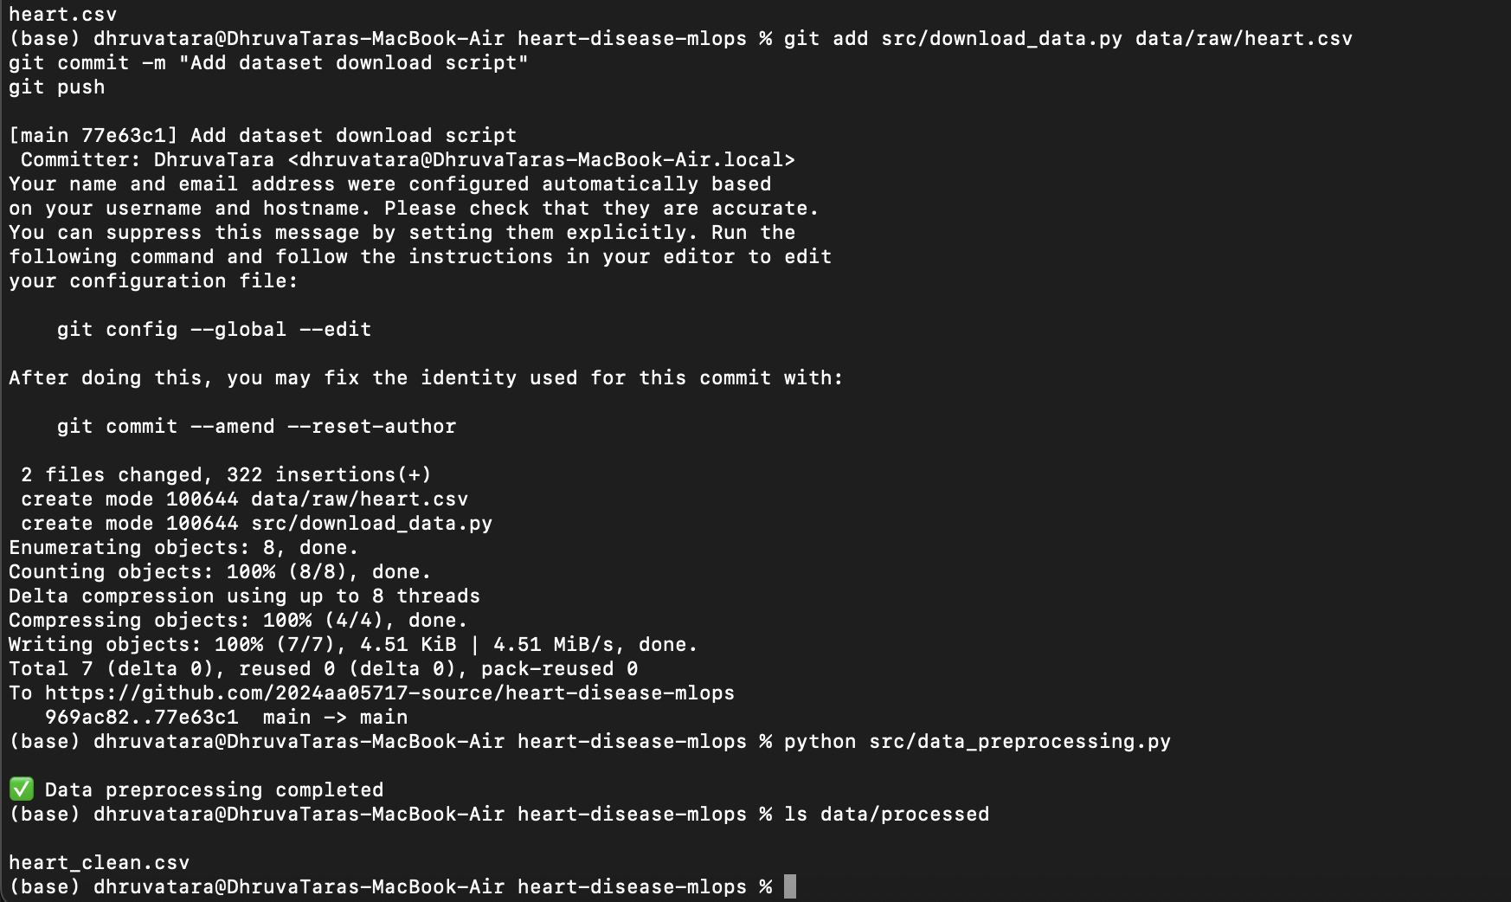
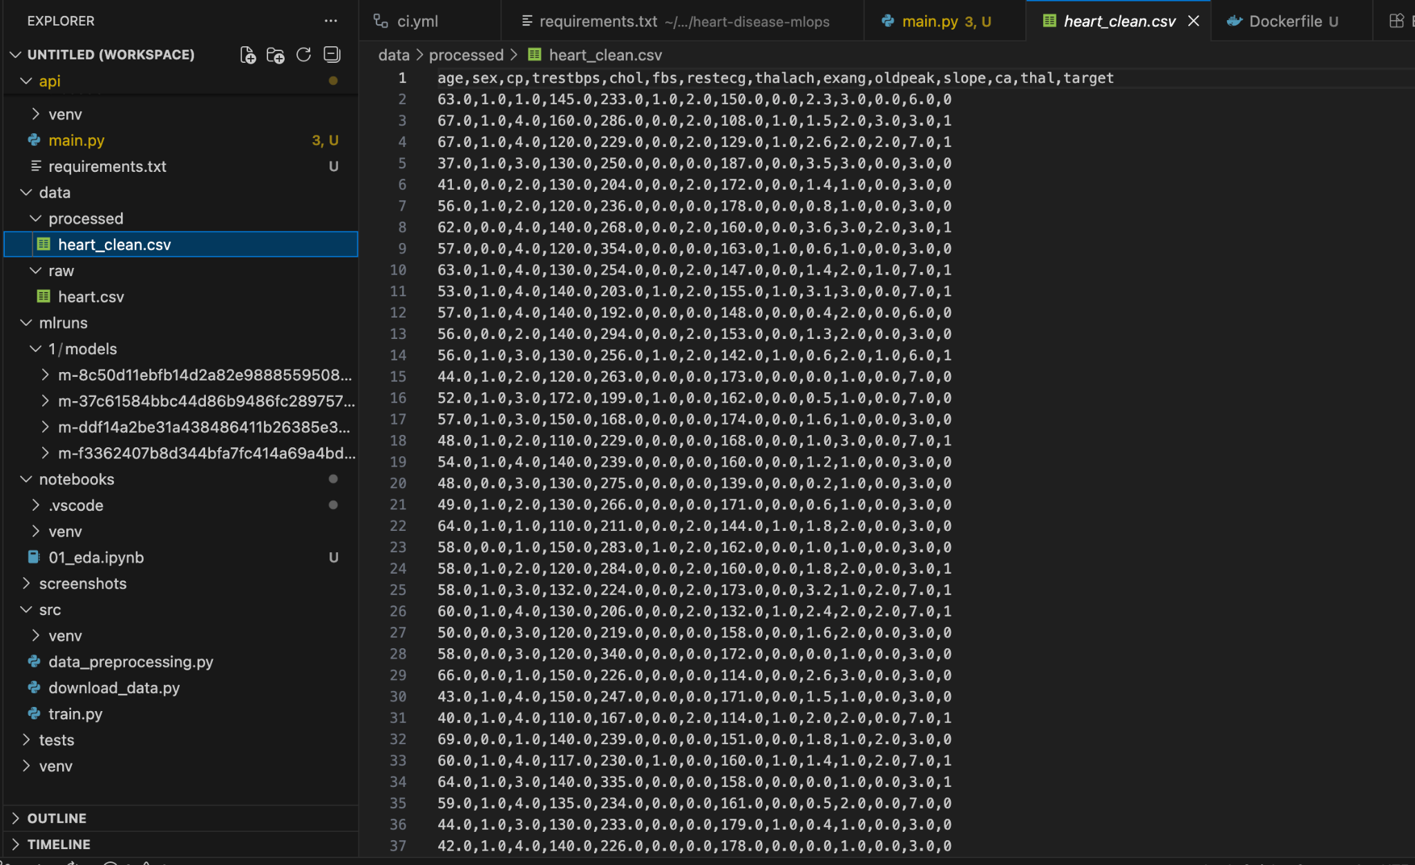
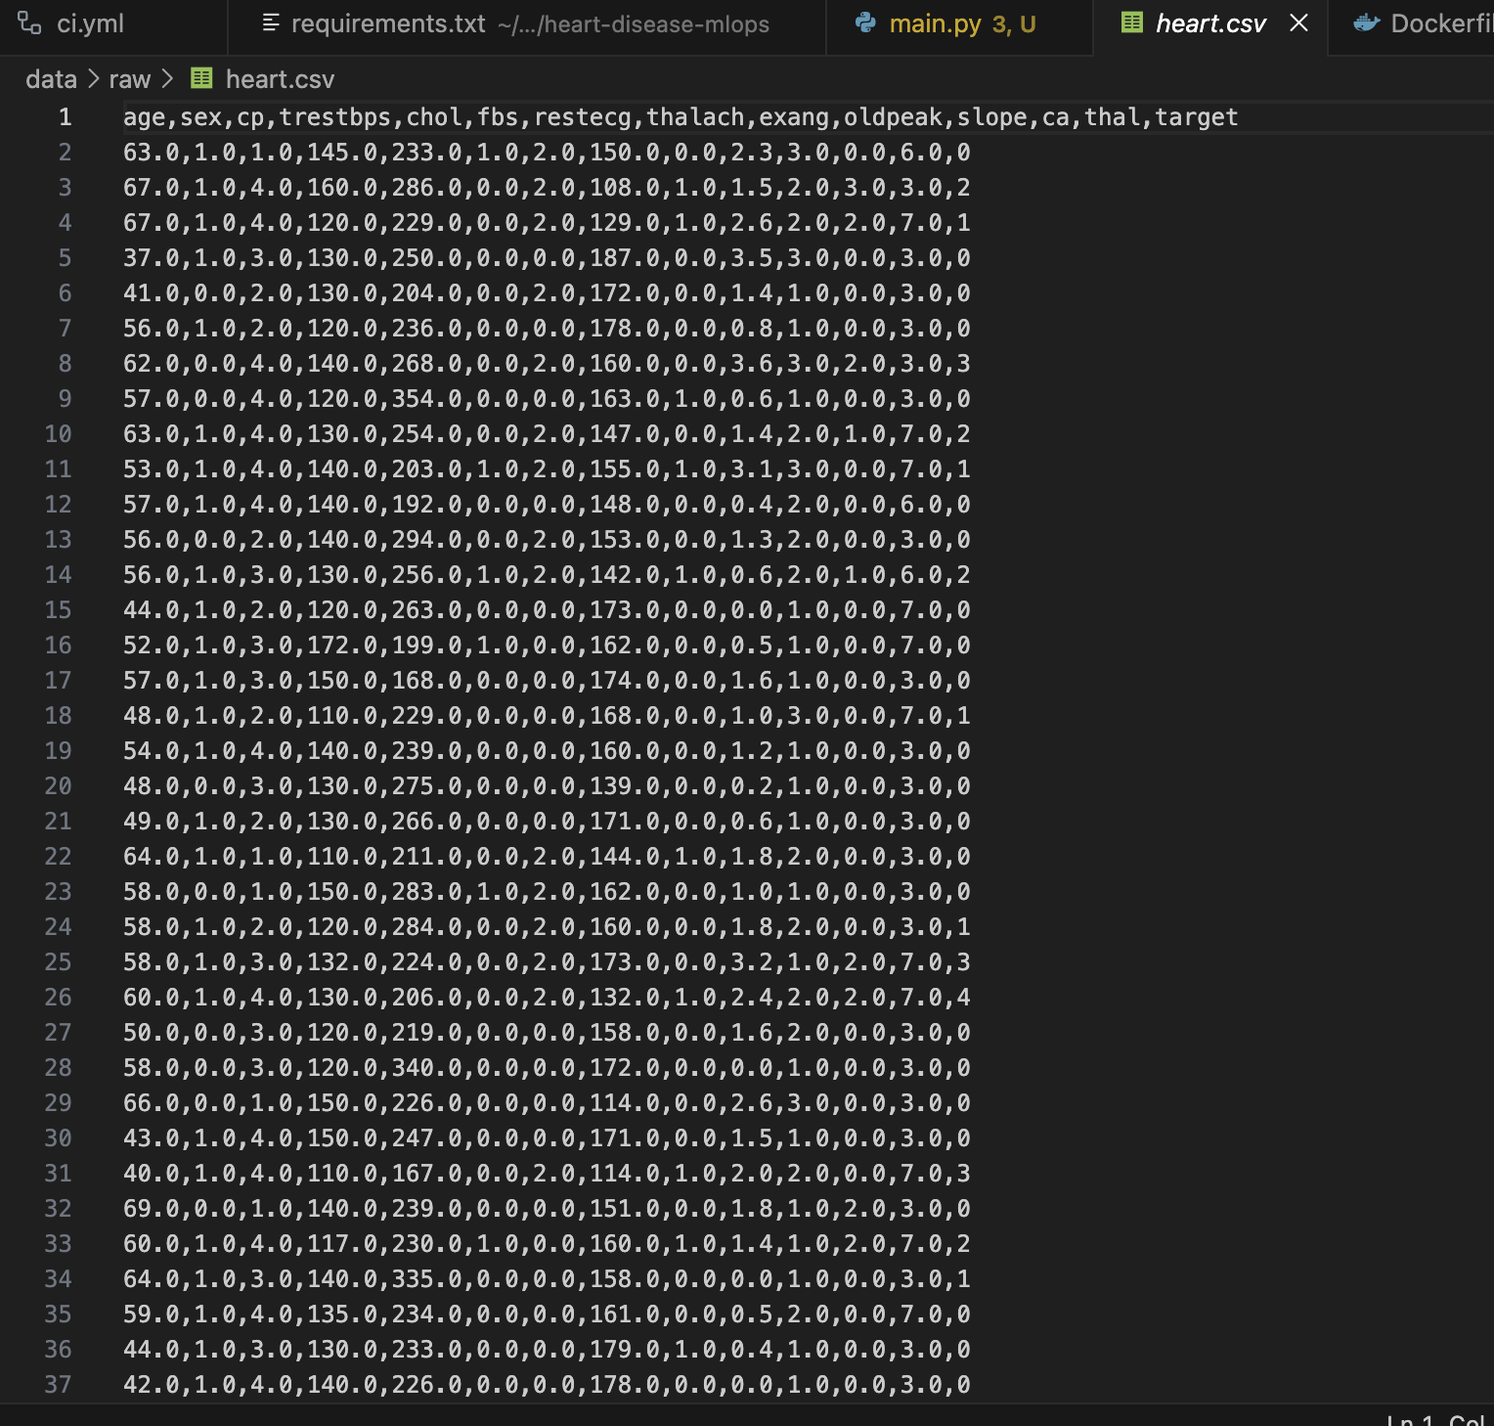

4. Model Training and Experiment Tracking
Two models were trained: Logistic Regression and Random Forest. MLflow was used to track experiments, including hyperparameters, metrics, and trained model artifacts. This enables transparent comparison and model versioning.

6.1 Models Implemented
Two machine learning models were trained:
Logistic Regression
o Baseline, interpretable model
o Serves as a reference for performance comparison
Random Forest Classifier
o Non-linear ensemble model
o Better captures feature interactions

6.2 Evaluation Metrics
· Accuracy
· Precision
· Recall
· F1-score
Random Forest demonstrated superior performance and was selected for deployment.

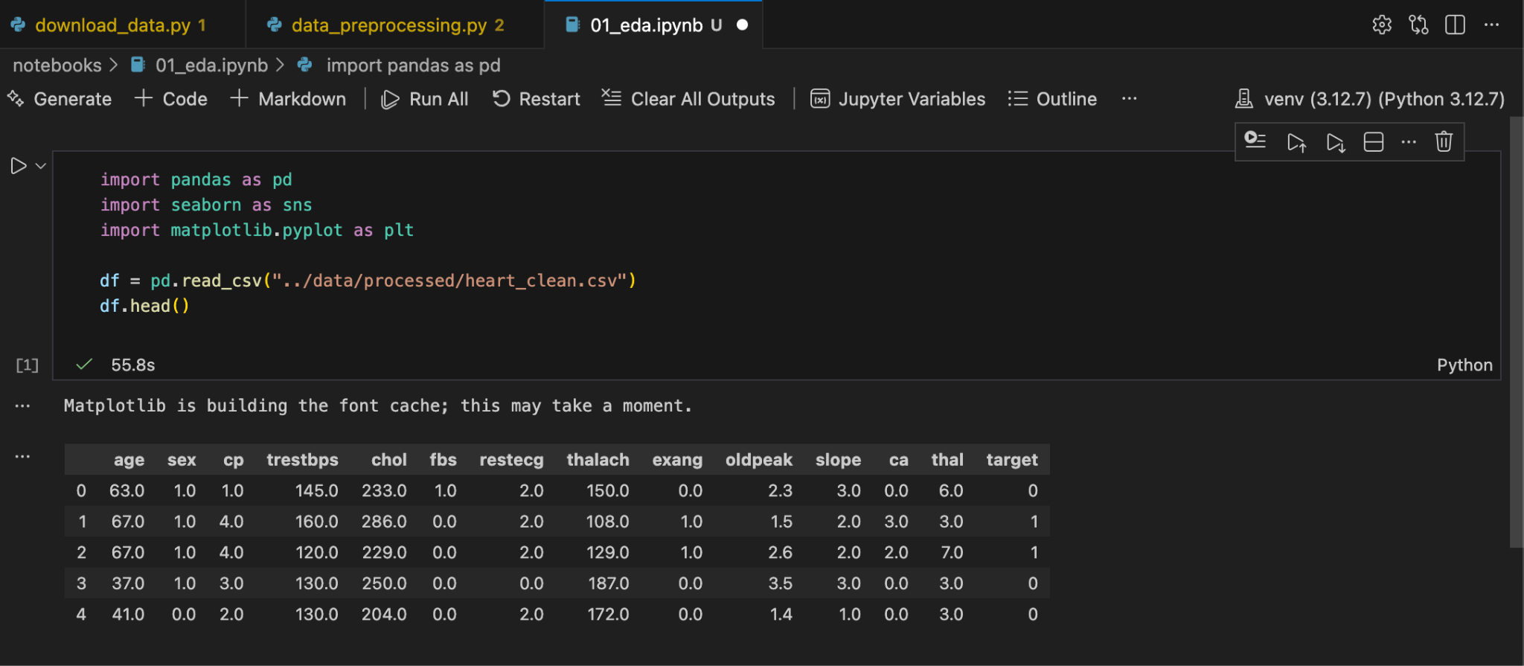
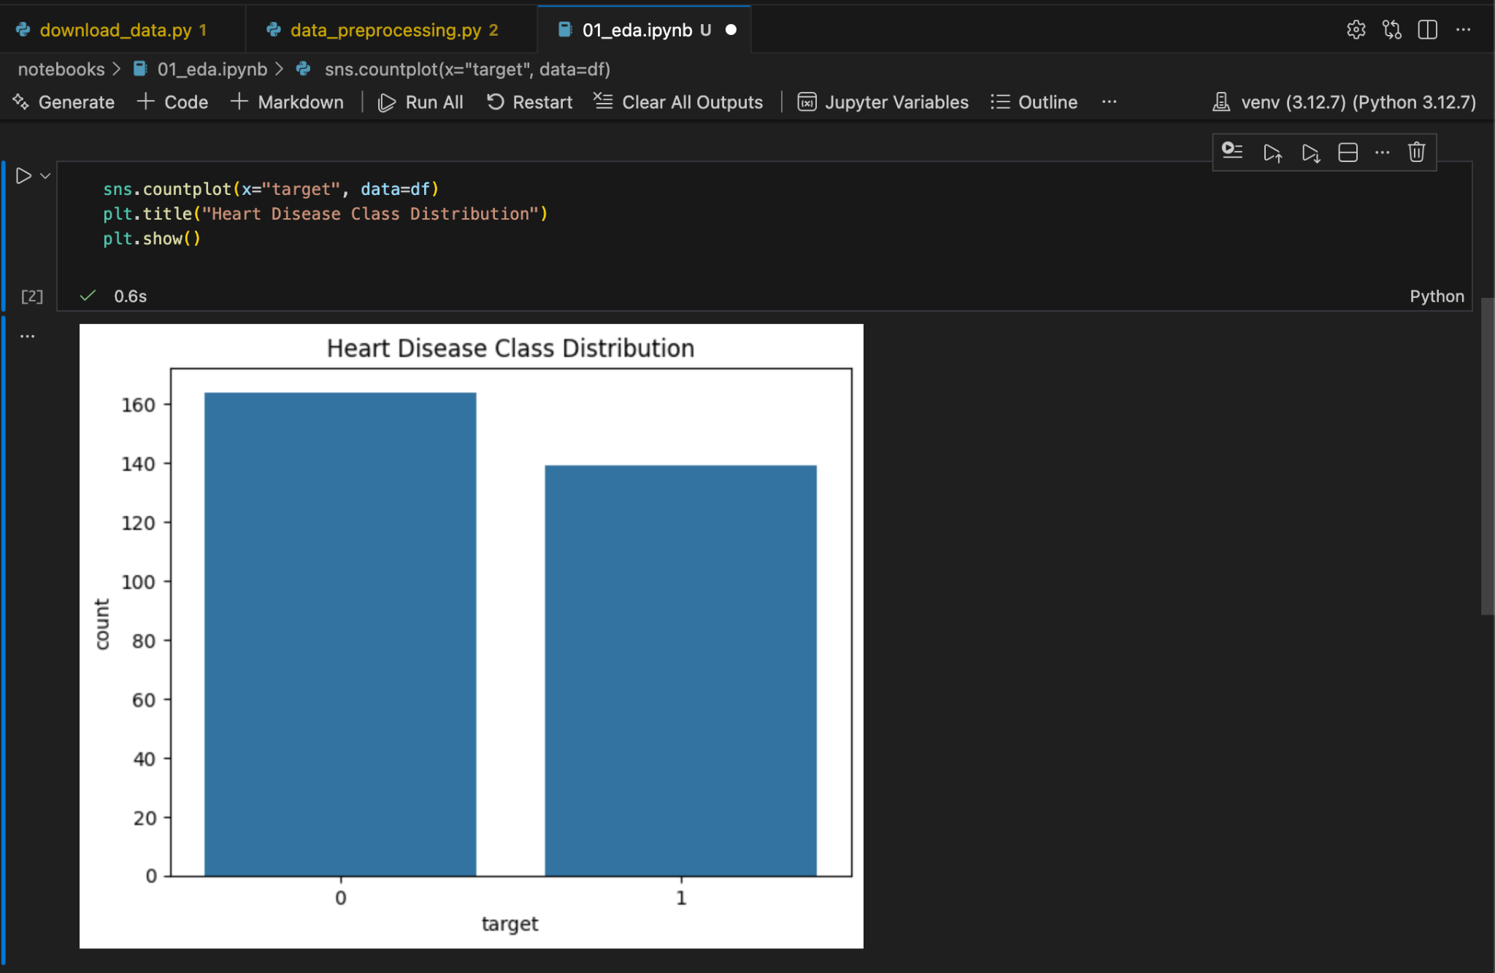
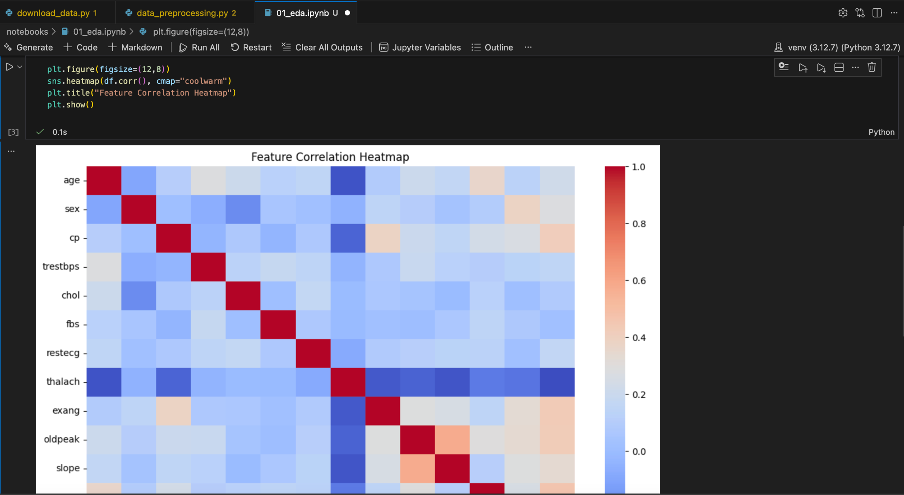
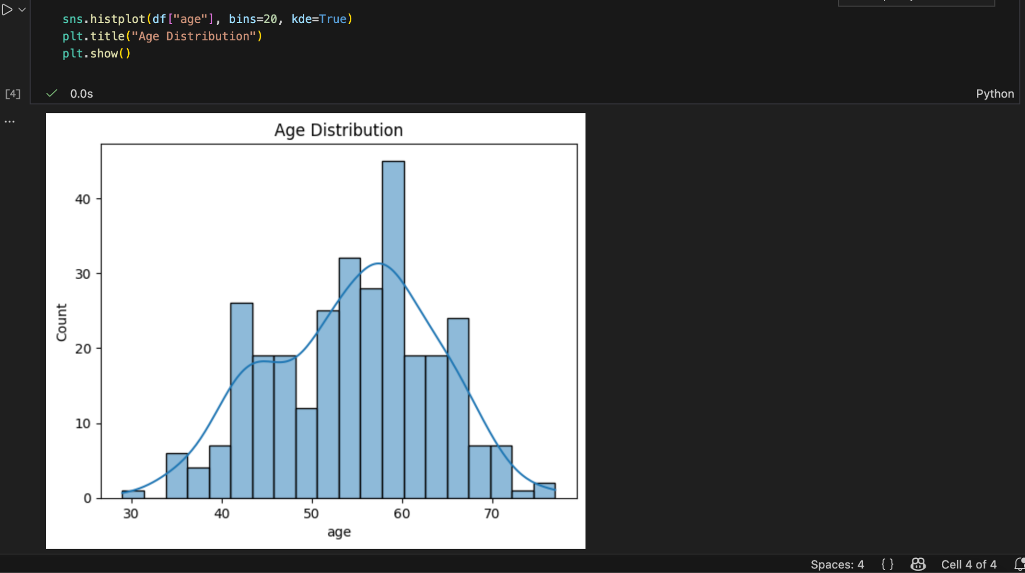

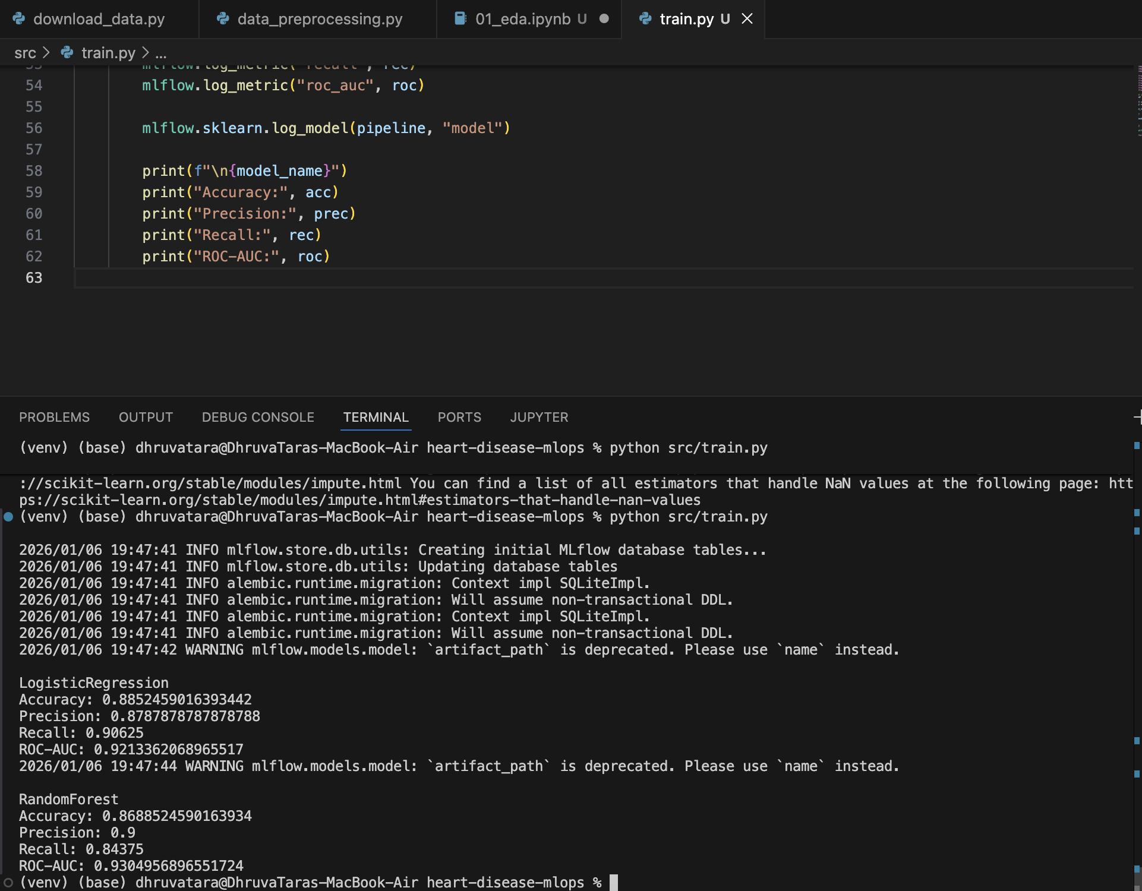

Model Selection and Management
Based on evaluation metrics, the Random Forest model achieved superior performance. Both models were registered in MLflow. Due to deprecation of stage-based transitions in the installed MLflow version, the production model was loaded using a runs-based MLflow URI, ensuring deterministic and reproducible inference.

MLflow was used extensively to track experiments.

7.1 Tracked Components
· Hyperparameters
· Evaluation metrics
· Model artifacts
· Run metadata

7.2 Benefits of MLflow
· Full traceability of experiments
· Easy comparison across models
· Reproducible training
(MLflow experiment comparison screenshots attached)

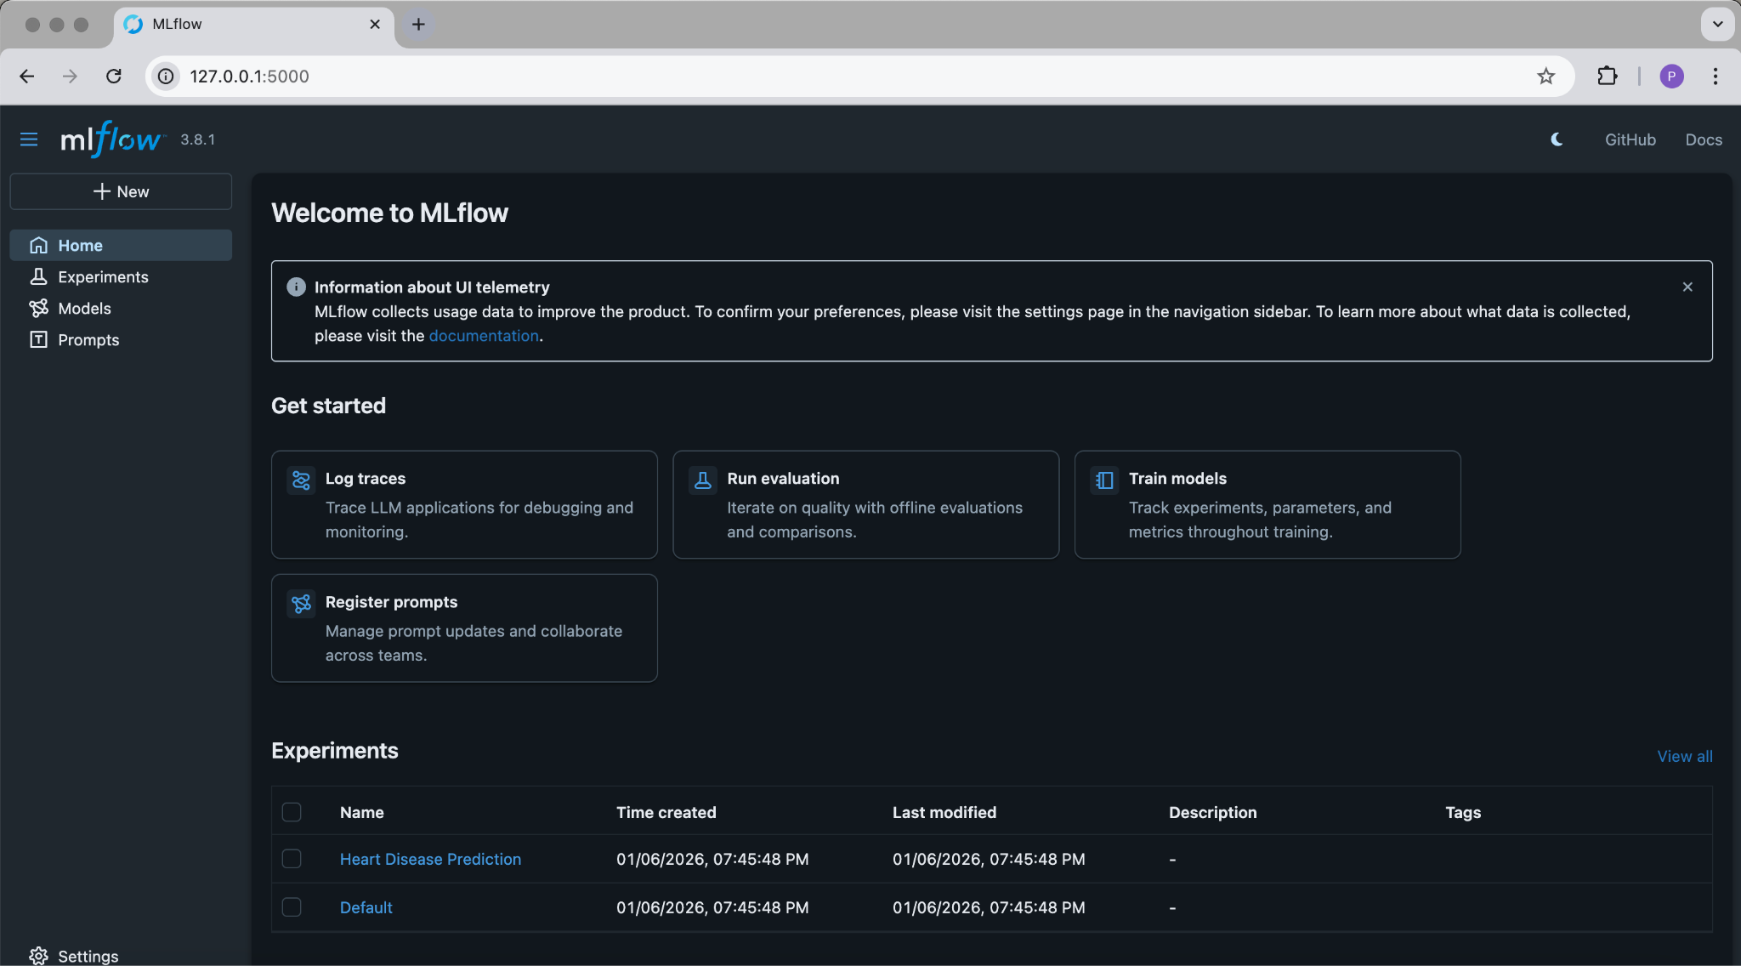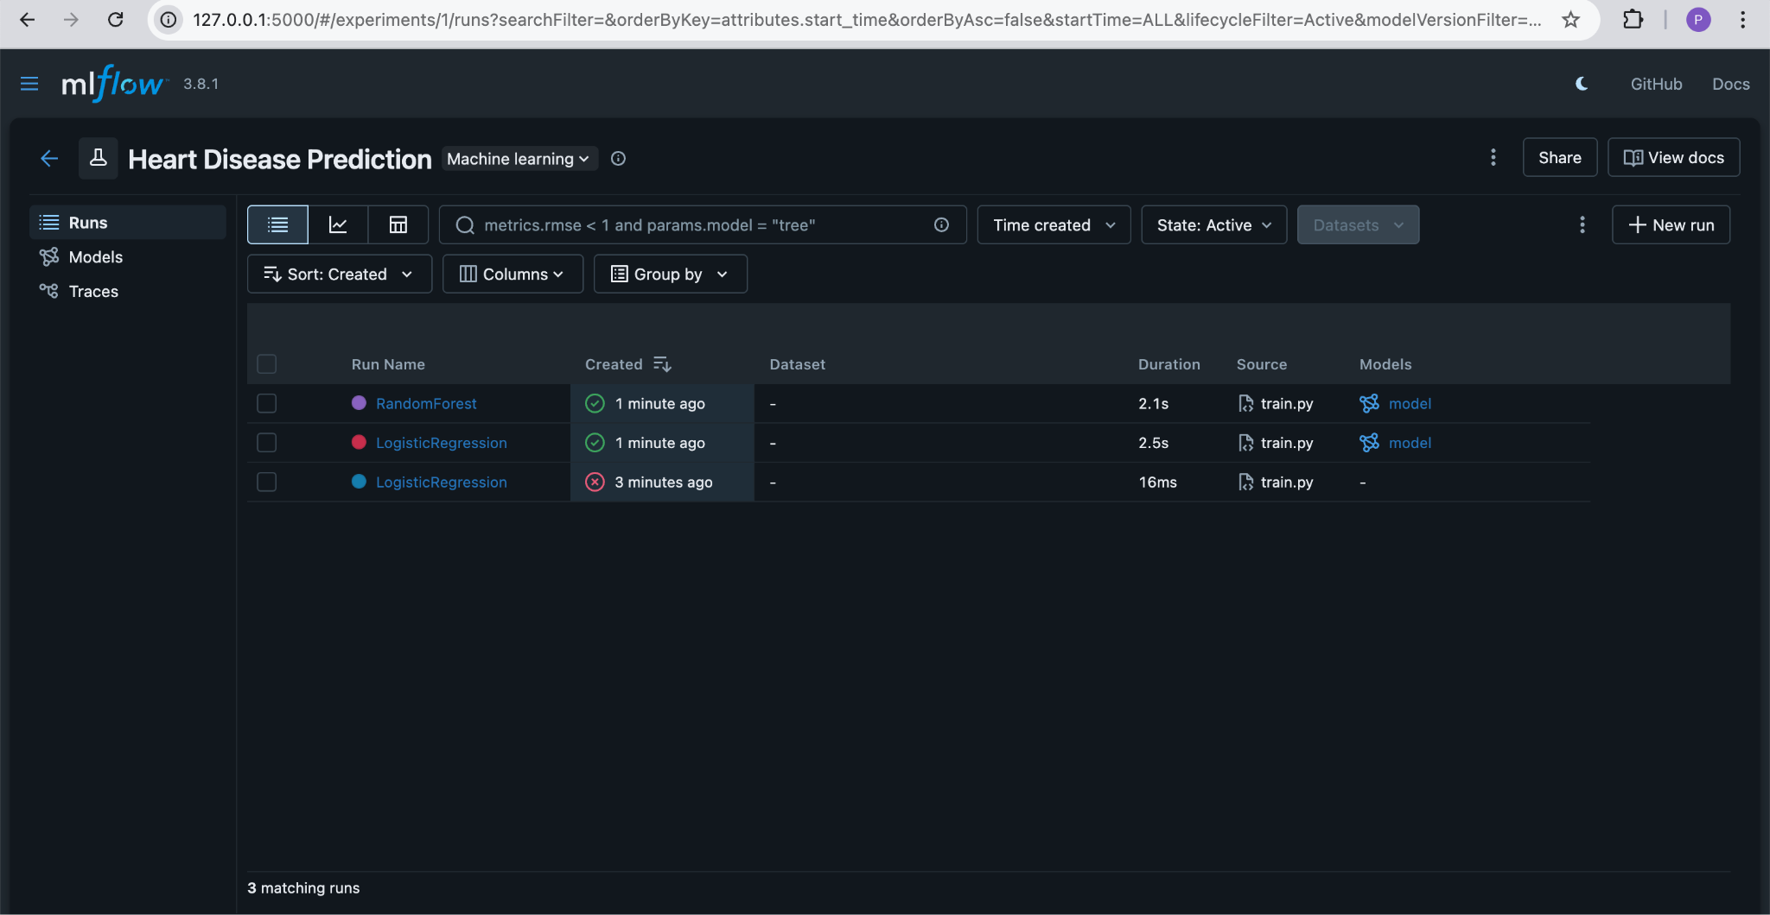
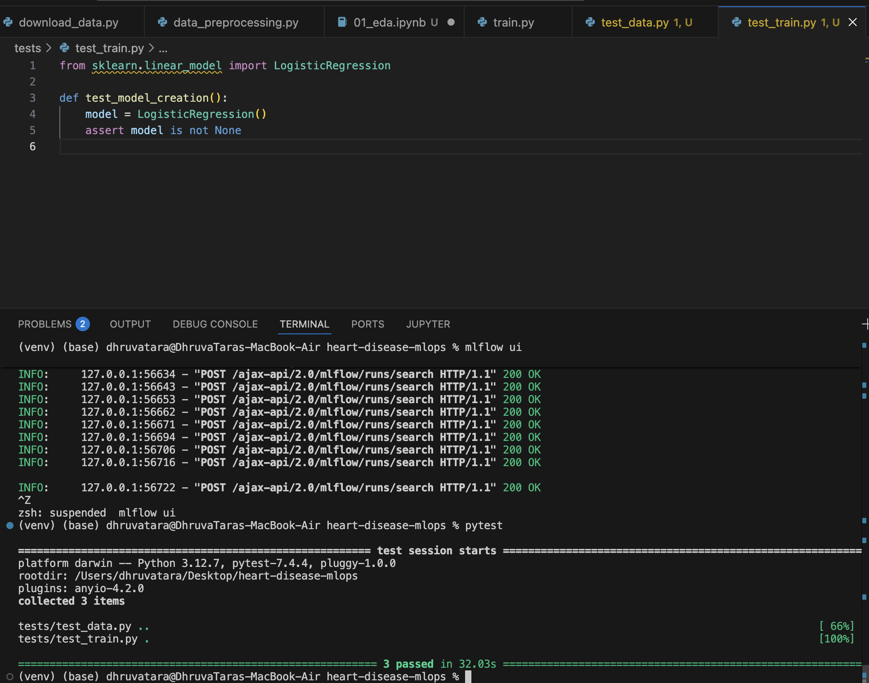

CI/CD Pipeline
A GitHub Actions pipeline was implemented to automate the ML workflow. The pipeline executes data ingestion, preprocessing, unit tests, and model training on every commit. This guarantees reproducibility and early detection of failures.

CI/CD pipeline was implemented using GitHub Actions.

8.1 Pipeline Stages
On every push to the main branch:
Code checkout
Python setup
Dependency installation
Data ingestion
Data preprocessing
Unit testing
Model training
This ensures early failure detection and full automation.

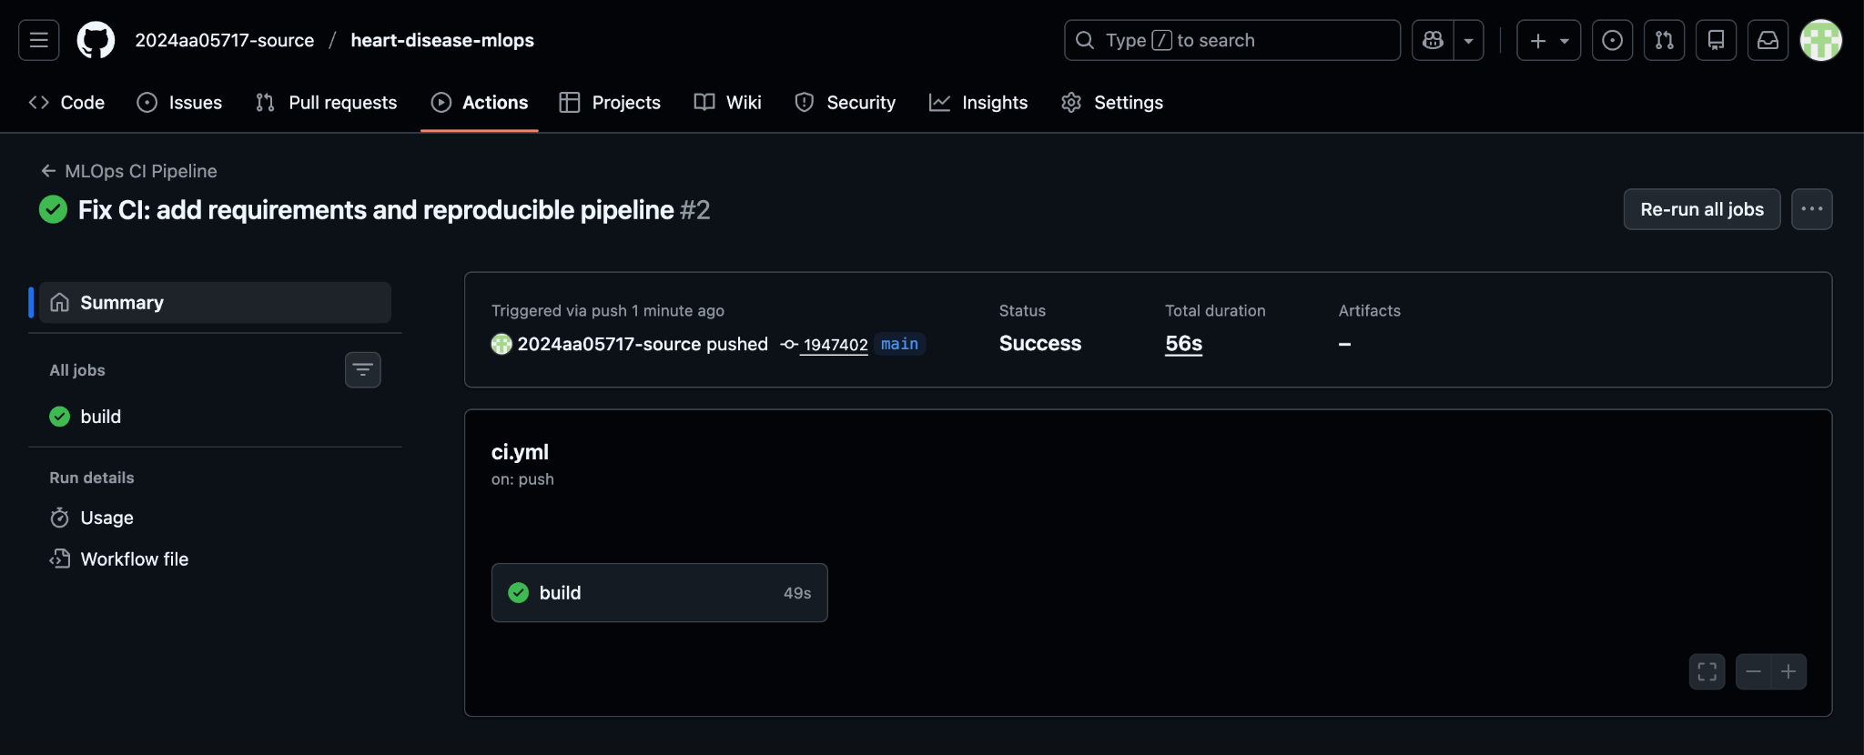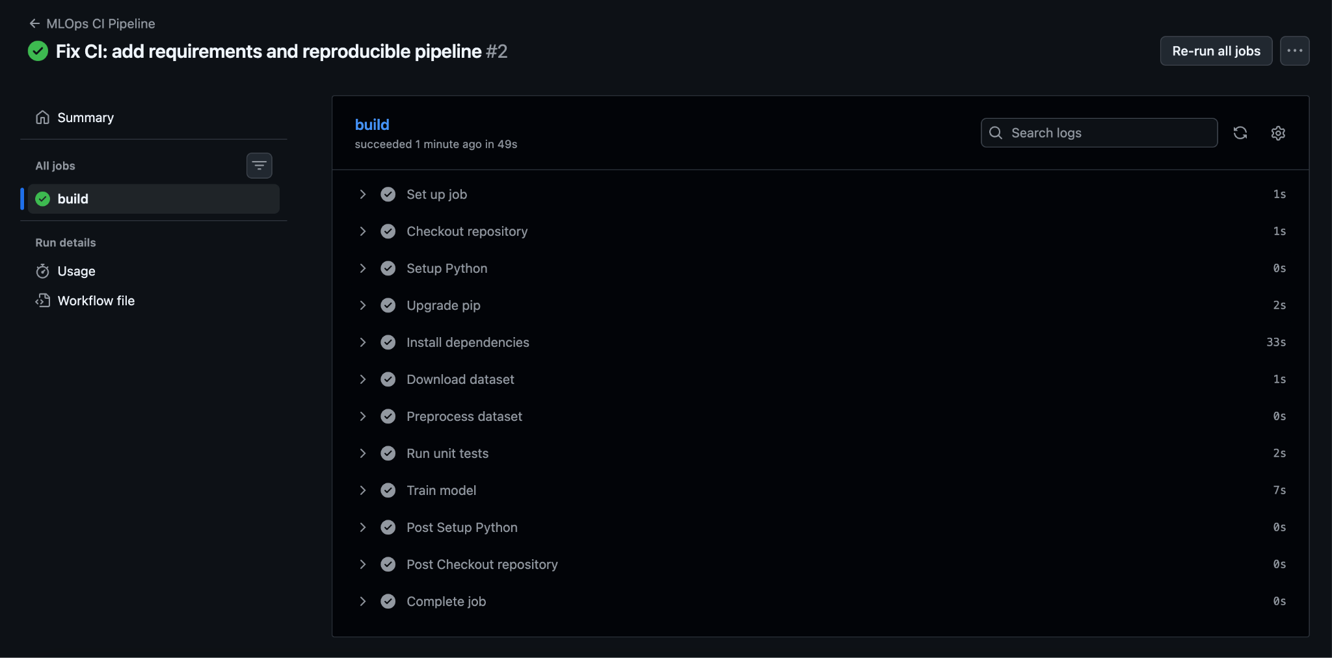

7. Model Serving Using FastAPI
A REST API was developed using FastAPI. The API exposes a /predict endpoint that accepts JSON input and returns model predictions. The trained model is loaded via MLflow’s pyfunc interface. Swagger UI is used for interactive testing.

A REST API was built using FastAPI.

9.1 API Endpoints
· GET / – Health check
· POST /predict – Model inference

9.2 Inference Workflow
· Input accepted in JSON format
· Converted to pandas DataFrame
· Prediction returned as JSON
Swagger UI provides interactive testing.

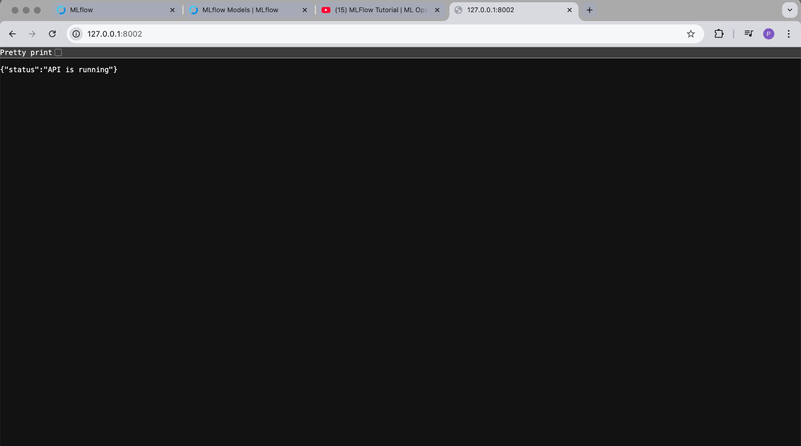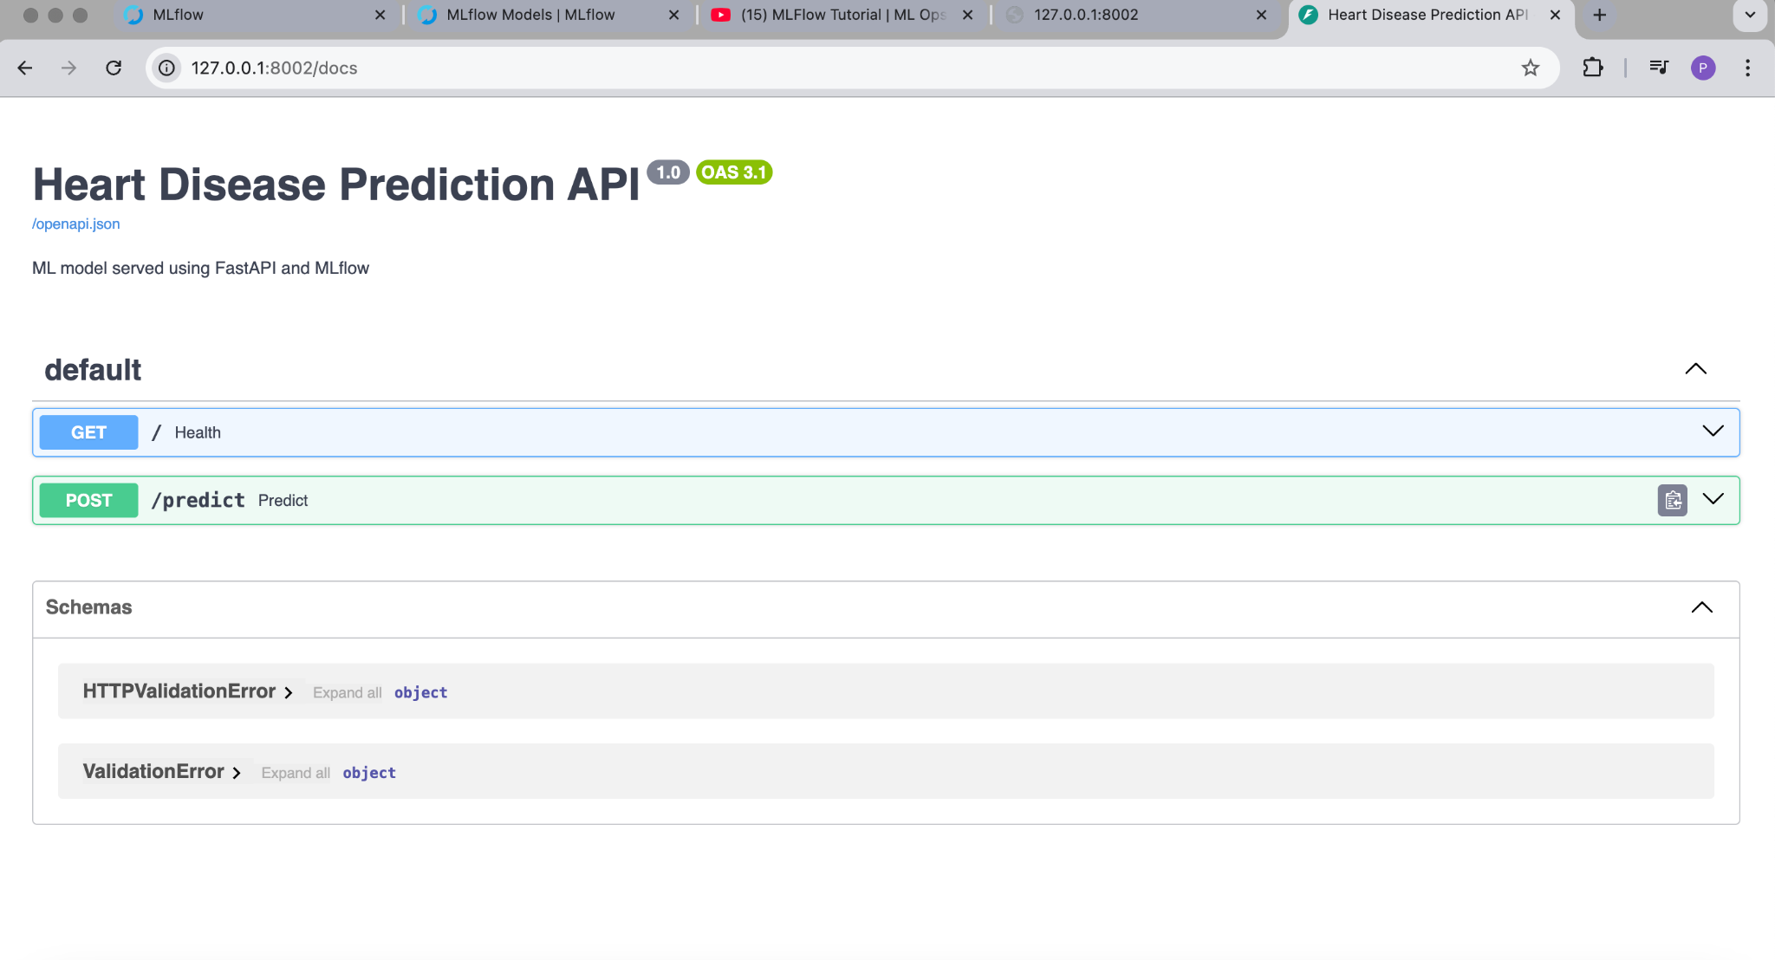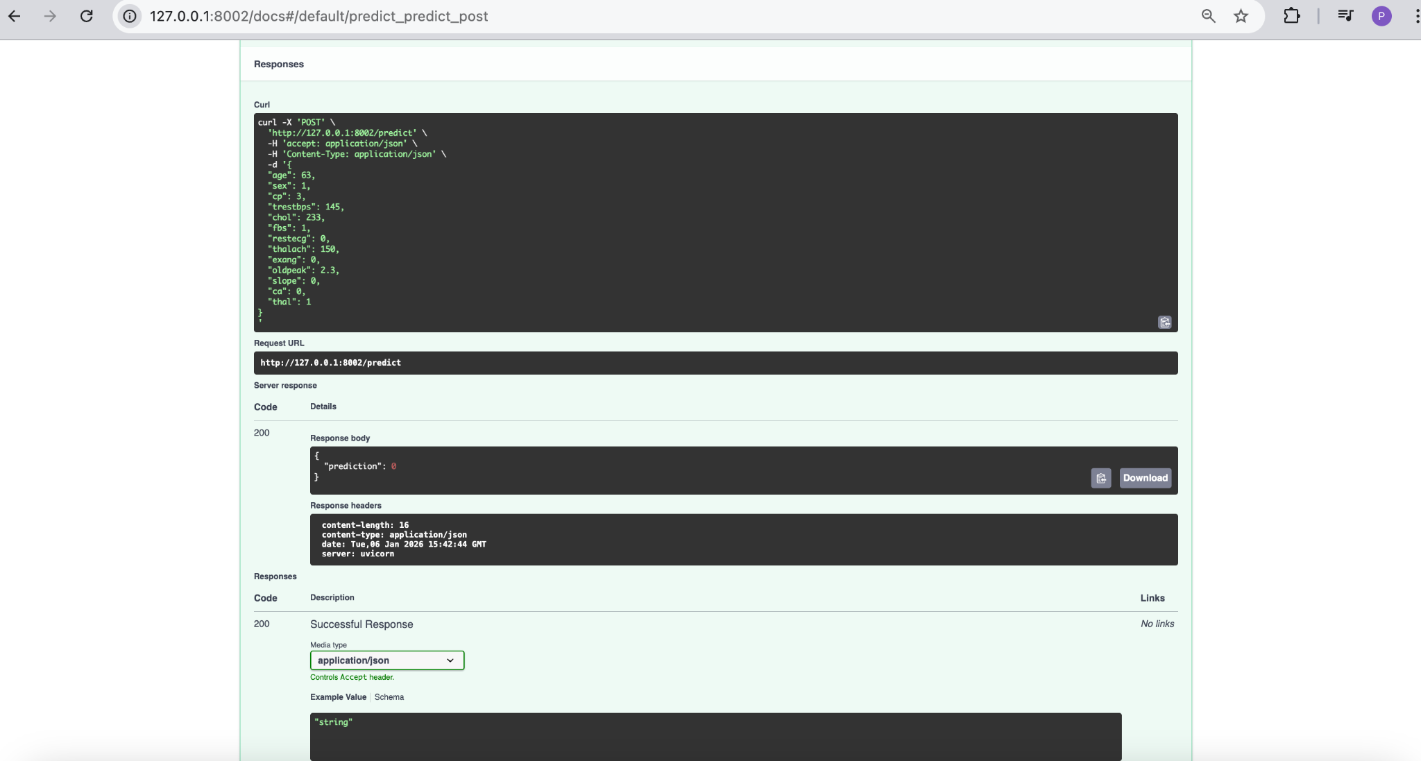

Containerization Using Docker
The FastAPI application was containerized using Docker. The MLflow tracking directory (mlruns) is mounted into the container at runtime, and the tracking URI is configured explicitly. This keeps the container stateless while enabling correct model artifact resolution.

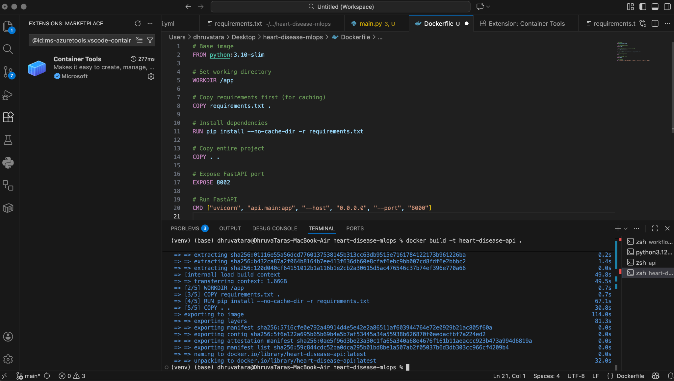

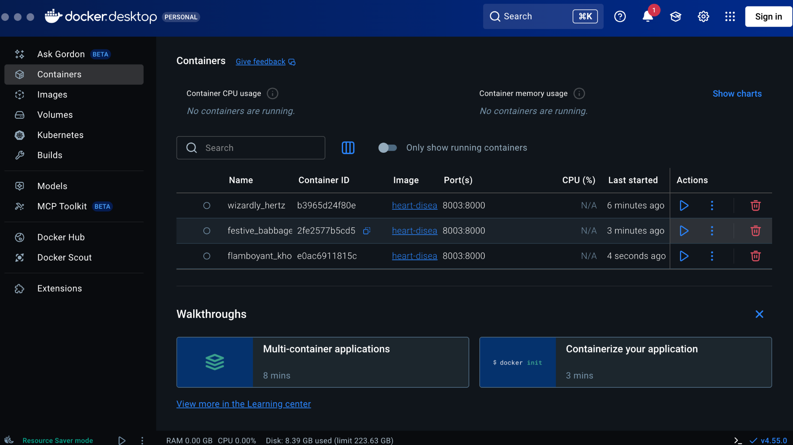

Conclusion
This project successfully demonstrates a complete MLOps pipeline using industry-standard tools. The solution ensures automation, reproducibility, and scalability, making it suitable for real-world machine learning deployments.
The combination of MLflow, GitHub Actions, FastAPI, and Docker ensures:
· Automated validation
· Reproducible training
· Portable deployment
· Clear governance of ML models
This workflow closely mirrors real-world production ML systems.

Code Repository
GitHub Repository:
https://github.com/2024aa05717-source/heart-disease-mlops
All source code, CI configuration, Dockerfile, and documentation are available in the repository.

Conclusion
This project successfully demonstrates a full end-to-end MLOps pipeline. By integrating experiment tracking, CI/CD automation, API-based serving, and containerized deployment, the solution aligns with industry best practices and provides a strong foundation for scalable machine learning systems.

